**WAVES EXERCISE ONE**

**SECTION A**

**1.**

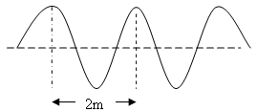

Figure above shows a wave produced in a string. If the frequency is 2Hz, at what speed do the waves travel along the string?

a. 0.5ms-1 b. 1.0ms-1 c. 2.0ms-1 d. 4.0ms-1

**2.** A longitudinal wave is one in which the

a) direction of propagation is parallel to that of the vibration producing it.

b) particles of the medium through which it travels move opposite to the direction of propagation.

c) direction of propagation is perpendicular to that of the vibration producing it.

d) particles of the medium through which it travels move together with it.

**3.** The number of complete oscillations made per second is referred to as

(a) periodic time (b) amplitude

(c) wave length (d) frequency

**4.** A source producing waves which travel a distance of 140cm in 0.08 s. If the distance between successive crests is 20cm, find the frequency of the source.

(a) 0.875Hz (b) 8.750Hz

(c) 87.500Hz (d) 8750Hz

5.

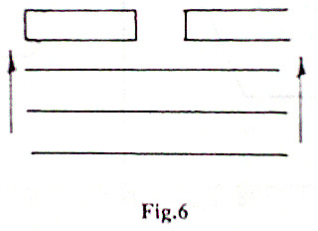

The diagram in the figure shows parallel wavefronts approaching a narrow gap. Waves passing through the gap are likely to under go

(a) Reflection (b) refraction

(c) diffraction (d) interference

6. Figure 3 shows waves spreading out from a point. The wavelength of the waves is

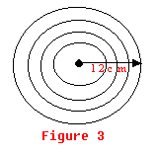

A. 3cm B. 6cm C. 9cm D. 12cm

**7.**

|  |  |  |
| --- | --- | --- |
| Vibrator | Wave Length | Frequency |
| Wave P | 1,500 m | 0.2 MHz |
| Wave Q | 500 m | …………. |

The table above shows readings obtained by using a vibrator which produces waves of a constant velocity. Find the frequency of the wave Q.

A. 0.07MHz. B. 0.3 MHz. C. 0.6 MHz. D.1.2 MHz.

8. Which of the following statements is true about the wave traveling from one medium to another

(i) its frequency and wave length change

(ii) its frequency and velocity change

(iii) its velocity and wave length change

(iv) only the frequency remains unchanged

A. (i) only B. (i) and (ii) only

C. (i) and (iii) only D. (iii) and (iv) only

9. Water waves travel a distance of 36cm in 6s and the separation of successive troughs is 3.0cm. Calculate the frequency of the waves

A. 2Hz B. 12Hz. C. 18Hz D. 72Hz

10. The figure below shows circular waves incident on a plane reflector. Which of the following patterns represents the reflected waves.

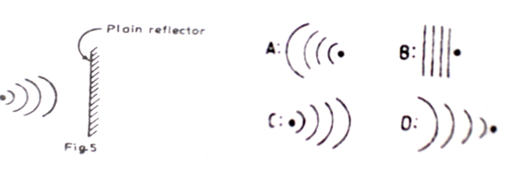

11. Which one of the following does not change when water waves travel through deep to shallow water

a) frequency

b) amplitude

c) velocity

d) wave length

12. Which of the following statements are true about refraction of waves

(i) the speed of waves changes

(ii) the wave-length changes

(iii) the direction of travel changes

(iv) the frequency changes

(a) (i) only

(b) (i) and (iii) only

(c) (ii) and (iv)

(d) (i), (ii) and (iii) only

13**.** Water waves are produced at a frequency of 5Hz and the distance between 10 successive crests is 18cm. calculate the velocity of the waves in ms-1

(a) 9ms-1 (b) 0.09ms-1

(c) 0.1ms-1 (d) 1ms-1

14. Which of the following change(s) when water waves travel from a deep to a shallow region

1. Velocity

2. Amplitude

3. Wavelength

4. Frequency

A. 1 only

B. 2and 3 only

C. 1, 2 and 3 only

D. All

15. A vibrator produces waves which travel a distance of 12m in 4s. If the frequency of the vibrator is 2Hz, what is the wavelength of the waves?

a) 1.5m b) 3m c) 6m d) 24m

16. A vibrator produces waves which travel a distance of 35cm in 2s. If the distance between successive wave crests is 5cm, what is the frequency of the vibrator

A. 3.5Hz B. 7.0Hz C. 14.0Hz D.87Hz

SECTION B

**1.** (a) (i) Describe how the speed of waves in a ripple tank can be

decreased

(ii) Explain the effect of decreasing the speed of the wave in (a) (i) on frequency

(b) With the aid of sketch diagrams, explain the effect of size of a gap on diffraction of waves

2. (a) With the aid of a diagram, explain the terms amplitude and

wavelength as applied to wave motion.

(b) Derive an equation relating velocity, V, frequency, F and wave length of a wave.

3. (a) What is meant by a standing wave?

(b) Figure 11 shows plane waves approaching a gap in a barrier.

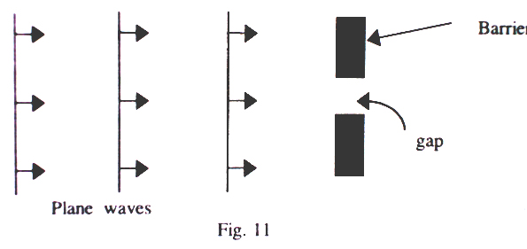

(i) Show the diagram, the appearance of the waves after the barrier.

(ii) What is the effect of reducing the size of the gap?

4.

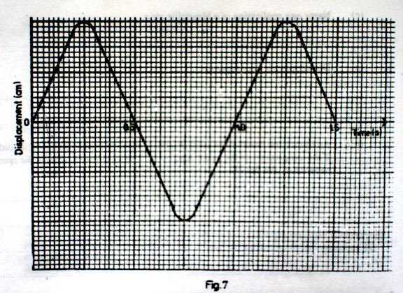

The diagram in the figure shows a section of a transverse wave of wave- length 4.0cm. find its

(i) frequency (ii) amplitude (iii) velocity

5. (a) The end Q of a rope is tied to a pole while the end P is moved up

and down as shown in the figure below.

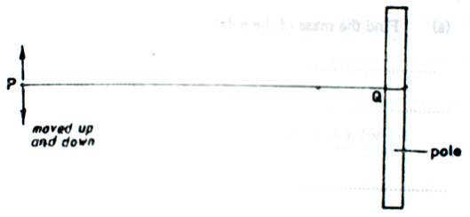

Sketch the resultant wave pattern between P and Q

(b) (i) Name the type of wave produced in (a) above.

(ii) Name one musical instrument which produces this type of wave.

**6.** (a) Describe how a straight wave is produced in a ripple tank.

(b) State the conditions of the occurrence of destructive interference of waves.

**7.** (a) What is a *transverse wave*?

(b) The diagram in figure 10 represents a wave traveling in water.

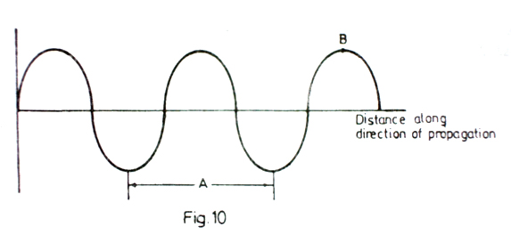

(i) Name the part labeled B .

(ii) If the distance represented by A is 20cm and the speed of the wave is 8.0 ms-1, what is the frequency of the wave?

**8.** (a) Explain the difference between transverse and longitudinal waves.

Give one example of each

(b)

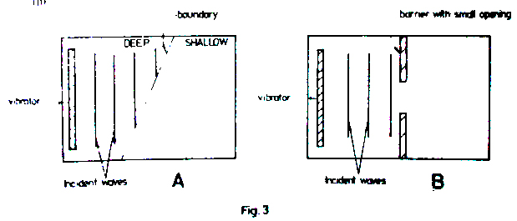

The diagram in the above figure represents a place view of horizontal ripple tanks set up to study characteristics of water waves. The vibrators were set up to produce plane waves

(i) Draw diagrams to show the wave patterns in A and B

(ii) Explain what happens to the plane waves in each case.

9. A vibrator in a ripple tank vibrates at 5Hz. If the distance between 10 successive crests is 37.8cm, calculate

(i) the wavelength of the waves

(ii) the velocity of the waves

10. The figure shows waves propagating towards a concave reflector.

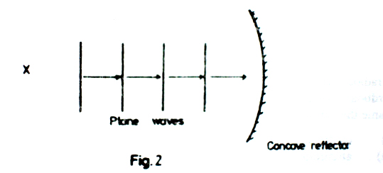(i) Draw a diagram to show how the waves will be reflected.

(ii) If the velocity of the waves is 320ms-1 and the distance between two successive crests is 10cm, find the period of the waves.

(b) Straight water waves travel from deep to shallow water as shown in the figure below

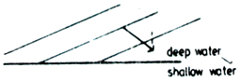

Copy and complete the wave front pattern in the shallow water.